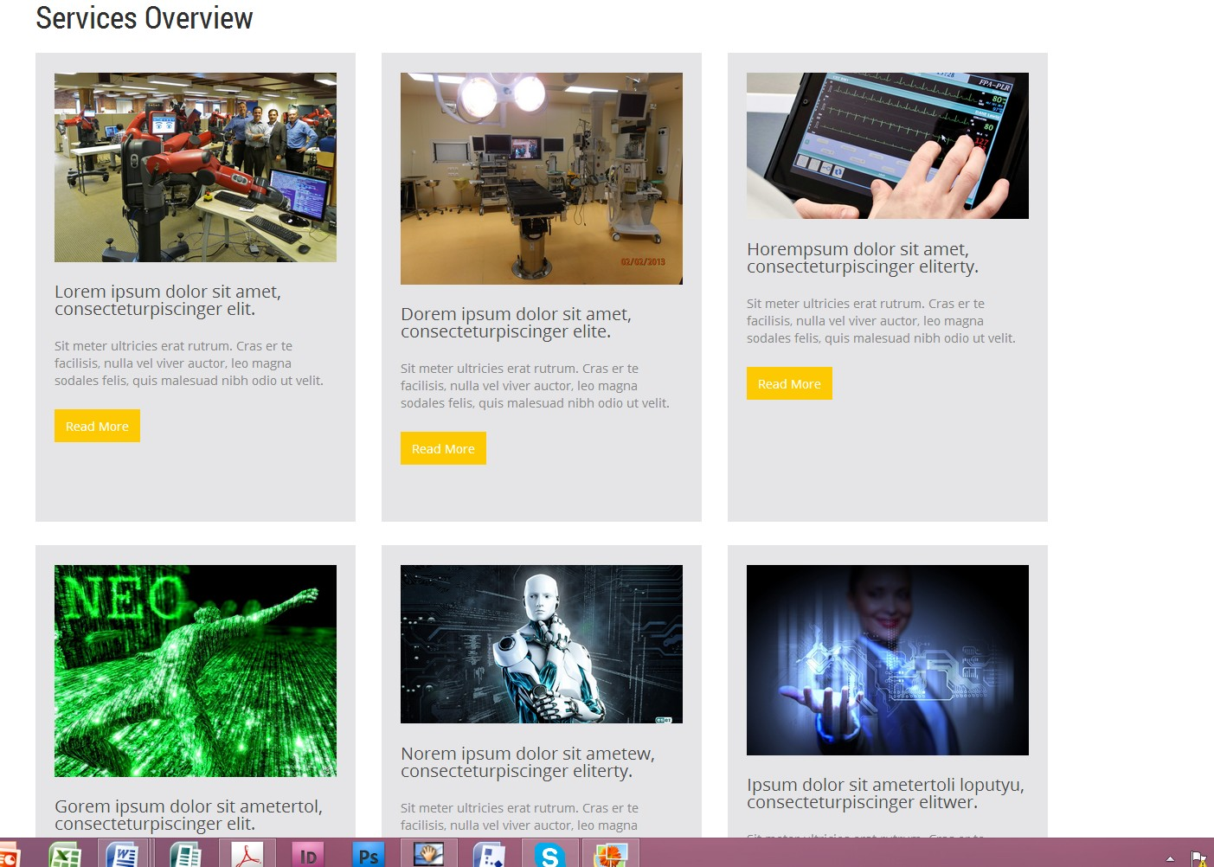

Previous Partner's Testimonials

Software Engineering

Hardware Engineering

Insert title "How We Can help You".

Insert a section "Why Consider Perfect Square"

Insert a short summary about the services we provide.